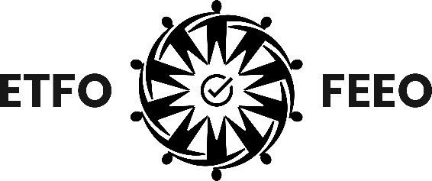

2026 Black History Month Poster
We Didn’t Cross the Waters Alone
#FutureGriot
The poster is a visual narrative that blends West African cosmology with northern landscapes tied to Black migration routes, such as Windsor–Detroit, Amherstburg, and Chatham–Kent along the Great Lakes.
Central Figure: A young Black boy imagined as a young griot, a modern keeper of memory. In many West African cultures, griots are the storytellers, musicians, and living libraries who carry history through voice, rhythm, and oral tradition. The child wears futuristic virtual reality goggles, which symbolize dual vision: how history is inherited, how the future is imagined, and how children hold both ancestral memory and possibility at once. His sweater is a traditional Nigerian print and his bright orange vest features an embroidered Henson patch, which is meant to represent that he is a descendent of Canadian pioneer Josiah Henson.
The microphone on the patch symbolizes the boy’s voice and his ability to be the sound of his generation. By placing this symbol on an ingenious Black child, the poster reclaims and centres the people who were historically omitted from the narratives in the image. He is not simply observing the scene; he is participating in the retelling of the stories they evoke. In this way, the poster positions the child as a carrier of ancestral memory, a translator of mythology into the present, and a future architect of how history will be told.
Black & Canadian Imagery: On the boy’s left, emerging from the frozen lake stands the winter manifestation of Yemoja, the Orisha of the great waters, memory, and protection. She is portrayed as a Black woman with long white braids holding a glowing lantern that symbolizes Harriet Tubman’s nocturnal journeys. Her inclusion merges several elements: water as memory, the light in the lantern that guides people across dangerous landscapes, and the unseen spiritual support behind every migration journey.
The train and railway to his right references the railroads that shaped settlement in Canada, including the infrastructure built through Black labour and, in particular, the Black porters who unionized in response to race-based discrimination. The railway routes also represent the pathways that freedom seekers navigated. The front of the train features the emblem of the Orisha Ogun, the builder, symbolically visualized as iron, tracks and technology, without depicting him directly.
The train grounds the mythic imagery in Canadian history and geography highlighted by the steam in the shape of the Tower of Freedom in Windsor. Silhouettes of travellers on a frozen bridge represent Black families crossing into new territory, the legacy of the underground railroad, and the courage and vulnerability of leaving one world to enter another.
Canadian Landscape & Natural Symbols: The winterberries, Canadian Rockies, snow-dusted cattails, northern cardinal, and frozen Great Lakes represent the contrast between the promise of “Canada West” advertised in the early 1900s and the actual northern climate, and the ecosystems that carry histories and stories in their waters and land. This landscape becomes a character – a witness – in the story.

The poster reminds us that our ancestors are always with us. Through migration and the trans-Atlantic slave trade, the
Black diaspora has never crossed waters alone.

