EXERCISING YOUR VOICE
Preparing for a Lobby Meeting

The following is a list of handy tips for conducting a lobby meeting with a Member of Provincial Parliament (MPP) or a school board trustee. It is important to remember that while all actions help to make a difference one of the most persuasive forms of lobbying is a face-
to-face meeting; this is why it is important to secure a meeting date.

NOTE: These tips are guidelines that can also be applied to other advocacy and lobby situations where you are seeking to create public policy change.

STEP ONE

Review your materials
Before requesting a meeting with an MPP or school board trustee it is important that you review any documents you wish to discuss, to familiarize yourself with the purpose and objectives of the meeting.
It might be helpful to make a few notes in case the staff person on the phone seeks additional information about your meeting request.

STEP TWO

Call to make an appointment
To schedule a meeting with an MPP, call their constituency office during office hours. Typically, the hours are posted on the MPP’s website.
Email can work as a back-up, but the first point of contact is best by telephone. For school board trustees, when possible try to reach them by telephone, but often email will be your primary point of contact.
When you call it is important to be polite and direct. During the call confirm the amount of time allotted for the meeting and provide your personal contact information. If the meeting is rescheduled, you will want the staff member to connect directly with you.
If you are not able to schedule the meeting on your first attempt, be sure to establish a timeframe for when you may call back to confirm a meeting date.
Be respectful and professional to the staff member and identify that you are a resident of the riding. It is not necessary at this point to indicate that you are a member of ETFO.






Join us in protecting high-quality public education at
BuildingBetterSchools.ca

STEP THREE

Re-confirm the meeting
A day or two prior to the meeting, follow-up with the constituency office to confirm who will be attending the meeting as part of your delegation, the topic for discussion, the time of the meeting and reinforce that you are seeking a constructive dialogue with the MPP.

STEP FOUR

Prepare for the meeting
Refer to the documents you reviewed prior to the meeting. Typically, your delegation will have half an hour for the meeting and not much more. Be succinct, direct and personable. Ensure that you make a direct ask for support to the representative; the goal is for the MPP or trustee to take action on the issue.
Consider bringing a parent or community partner with you to the meeting as part of the delegation.
Agree in advance what subjects and points everyone in the delegation will cover. It is recommended that you limit the delegation to a maximum of five people with a maximum of three designated speakers.

STEP FIVE

Establish roles
In your meeting delegation it is important to have designated roles. For each meeting you should establish a spokesperson,
a notetaker, someone to act as a photographer to ask and initiate taking a photo, and a timekeeper to help keep the meeting on track and ensure that a direct ask for support is made.

DAY OF THE LOBBY MEETING

Pre-meet at least 15 minutes before the meeting
During your pre-meeting review the roles,
objectives and confirm the notetaker.
As a reminder, the notetaker should not have multiple roles because it is vital that any commitments are recorded. The notes will be your record of the meeting and will be needed for any follow-up.

Remember – often, the MPP or trustee has less experience than you do.
Politicians are not experts; they have good staff
to supply information, but that information is often one-sided. Don’t be intimidated; be confident. Talk as you would talk to your neighbour and look them in the eye.
Don’t be in awe of them and keep it simple.

Confirm who is in the room
Introduce your delegation. Name the area each person lives in, the riding and any relevant group or membership affiliation.

Stay focused on the purpose of the meeting
Avoid long introductions and small talk that will diminish your meeting time. Personal dialogue can be a tactic to avoid meaningful discussion, your timekeeper can help redirect and focus the conversation.

Provide a copy of any fact sheets or documents
If available, present a lobby kit and leave it behind with the representative to review after the meeting. When discussing information
on fact sheets or other resources, you should also provide a personal story about your direct experience in the classroom.

Outline the direct ask for support from the MPP or trustee
It is perfectly acceptable to review any relevant documents with the MPP or trustee. Read the direct ask for support from your lobby documents.

Find out what they think and
listen carefully
Active listening is an essential part of effective
advocacy. Observe both what is said and the body language. You will not know what argument will make the most impact unless you find out what their concerns are.
Ask what the MPP or trustee believes or feels about the issues you are discussing.

Correct wrong information
Remember, elected officials are busy people and may not be well informed on all the issues and/or the impact policy has on the classroom. Share your personal experiences, provide specifics on issues and dispel incorrect information.

Affirm community support for increased funding for public education
Reinforce that parents, community members and educators, the voters in their riding, are concerned about the underfunding of public education and the impact on children.

Leave with an understanding of what the MPP or trustee will do
We want a commitment to take action. Before you leave, repeat back the commitments you understood they made to you or ask what they will do to offer support. Ask how they will show support and when any actions will be taken.

Capture the meeting with a photo
It is important to capture the meeting, even if you don’t think the meeting outcome was positive towards ETFO’s position.
A photo reinforces the advocacy work that you have done, and it is a great visual to use on social media to thank the person for the meeting and re-state the request for support.

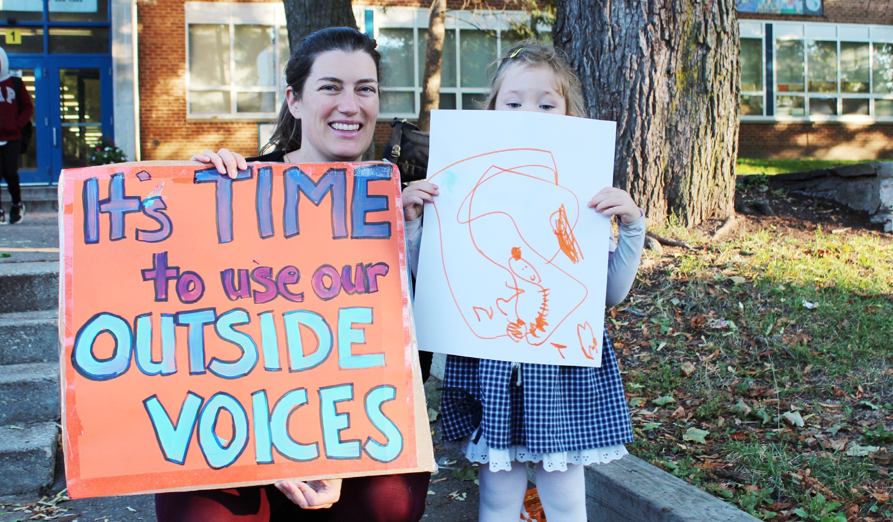

AFTER THE LOBBY MEETING

Write a short message and post the photo on social media
As Canada’s largest education union, representing more than 83,000 teachers and educational professionals, ETFO has name recognition for its social justice work, collective strength and political power. Social media platforms and online engagement help elevate the positive image of professional educators and ETFO’s influence as an informed advocate.
Keep your post short, offer thanks for the meeting and mention any commitments made or what you discussed. Tag the MPP or trustee to the post.
Participate in the public conversation online by including a hashtag in your post. Hashtags are keywords that allow users to share posts on the same topic easily. This will also help other social media users to see your post and comment.

Recommended hashtags to use: #ETFO #OntEd #ONpoli
We would recommend that each post include a maximum of three hashtags.

Email your report to the
provincial office
Be sure to complete the short, report-back form and email it, alongside a photo from the meeting if available to: communications@etfo.org.

Write a letter
A written letter can be sent by email but should also be sent as a hard copy with your signature via postal mail.
The purpose of the letter is to confirm the discussion, any agreements and re-assert the call for support. Include the following:
- ETFO’s position;
- Who was present at the meeting;
- Any follow-up questions or issues raised during the meeting to which you are seeking an answer;
- Any commitments or actions that you are looking for;
- A timeframe for follow-up; and
- Your contact information.

Keep any commitments that you made
If you promised to send the MPP or trustee additional information do so immediately after your meeting. Don’t delay.

Report back to your base
Keep the local executive/membership, activists and community partners in the loop about the meeting and any developments.



Elementary Teachers’ Federation of Ontario (ETFO) 136 Isabella Street | Toronto, ON Canada | M4Y 0B5 416-962-3836 | 1-888-838-3836

