Asian Heritage Month 2026

SPEAK PEACE

Classroom Connections

The Arts
Visual Arts
- Learn how to fold origami paper cranes or other animals. (Elements of Design - shape and form)
- Research other forms of paper arts such as jianzhi from China, shadow puppetry from Thailand, calligraphy, etc.). (Exploring Forms and Cultural Contexts)
- Ask students, “What does peace look like to you?” Invite learners to illustrate their thoughts with words and pictures. Create posters to promote peace in your school community. (Reflecting, Responding, and Analyzing)

Language Arts
Comprehension: Understanding and Responding to Texts
- Read about Asian Canadian activists who are seeking a more peaceful world. What motivates these activists? How do they spread their message?
- Read Sadako and the Thousand Paper Cranes by Eleanor Coerr. Invite students to write reflections from different characters’ points of view.
Composition: Expressing Ideas and Creating Texts
- Journal prompt: How do you create peace in the world? Give examples of peaceful actions you’ve seen or done in your classroom, school, community, or in your home.

Mathematics
Data Literacy
- Invite learners to collect data about languages spoken by students, staff, and/or others in the school community. Select the graph best suited to represent the data and display the data in the graph.

Social Studies/Geography
Gr. 2 Global Communities; Gr. 6 Canada’s Interactions with the Global Community; Gr. 8 Global Inequalities: Economic Development and Quality of Life
- Using the language guide on the following pages, map where the languages that appear in the poster are spoken on a map of Asia.
- Find out more about the International Campaign to Abolish Nuclear Weapons (ICAN) or other organizations that are working toward peaceful solutions to global problems.
- Learn about the Nobel Peace Prize and find out who has been awarded the honour in the past. What did the organization or individuals do to be recognized? Is there a person or group you think deserves recognition?
- Read about the United Nations Sustainable Development Goals (SDGs) and create infographics to highlight each one.

Asian Heritage Month 2026

Language Guide
The poster’s background features the word “peace” in different Asian languages. There are over 2,000 languages and dialects spoken across Asia.
The poster has a table with four columns. From the left to the right, the first column has sample images or words for “peace” that you might hear in Ontario classrooms and communities. The second column contains the language of origin, the third column shows the location where they’re spoken, and the fourth column illustrates how to pronounce the word peace in each language using English characters.

Column 1

 | Language | Location | English  Pronunciation
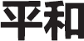 | Japanese | Japan | HEY-wah
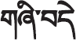 | Tibetan | Tibet, India, China | SHI-dey/SHI-bey
diyakrata | Maranao | Philippines | dee-ya-krat-ah
 | Thai | Thailand | KHWAAM-saa-nope
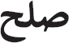 | Farsi (Persian) | Iran, Iraq | solh
perdamian | Indonesian | Indonesia | per-DA-may-an
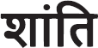 | Hindi | India | SHAN-tee
kapayapaan | Tagalog (Pilipino) | Philippines | ka-pa-ya-PAAN
paix | French | Canada, France | pay
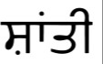 | Punjabi (Punjab) | Pakistan, India | SHAN-tee
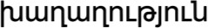 | Armenian | Armenia | kaa-gaa-gut-YOON
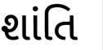 | Gujarati | India, Pakistan | SHAN-tee

Column 2

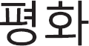 | Korean | Korean Peninsula | pee-YONG-hwah
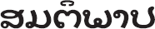 | Lao | Laos | SUN-tee-pap
 | Mongolian Cyrillic | Mongolia | a-mar aam-gal-an
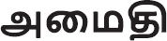 | Tamil | India, Sri Lanka | aa-MAI-tee
 | Turkish | Turkey, Cyprus | BAR-ıs
 | Vietnamese | Vietnam | HWA-bin
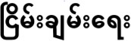 | Burmese | Myanmar | nee-chan-yee
kev thaj yeeb | Hmong | S. China, Vietnam,  Laos, Thailand | kev-thaj-yeeb
sühl | Azerbaijani (Azeri) | Azerbaijan | sool
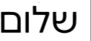 | Hebrew | Israel | sha-LOME
Column 3

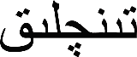 | Uighur (Uygur) | China, central  Asia | TINCH-lick
kappia | Ilocano | Philippines | ka-PEE-ya
 | Malayalam | India | sa-MAAD-hy-nam
tinchlik | Uzbek | Uzbekistan,  central Asia | TINCH-lick
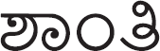 | Kannada | India | SHAN-tee
 | Kazakh | Kazakhstan | bey-bit-SHI-lick
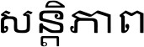 | Khmer | Cambodia | SAN-tep-heap
 | Kurdish | Kurdistan (central  Asia) | AHUSH-tee
parahatçylyk | Turkmen | Turkmenistan,  central Asia | pah-ra-HAT-chu-luk
 | Urdu, Kashmiri | Pakistan, India,  central Asia | amn

Column 4

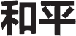 | Chinese – Mandarin &  Cantonese | China, Singapore, Vietnam | HU-ping (Mandarin) WUH-ping  (Cantonese)
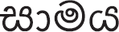 | Sinhala | Sri Lanka | saa-ma-ya
tentrem | Javanese | Indonesia | TEN-TER-am
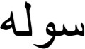 | Pashto | Afghanistan, Iran,  Pakistan | SO-la
kedamaian | Indonesian  (Bahasa) | Indonesia | ke-de-MAI-an
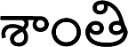 | Telugu | India | SAN-tee
kalinaw | Cebuano | Philippines | ka-LEE-naw
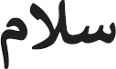 | Arabic, Ishkashmi | west and central  Asia | sa-LAAM
vakacegu | Fijian | Fiji | va-ka-THEH-ngo
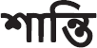 | Bangla, Bengali,  Assamese | Bangladesh, India | SHAN-tee

