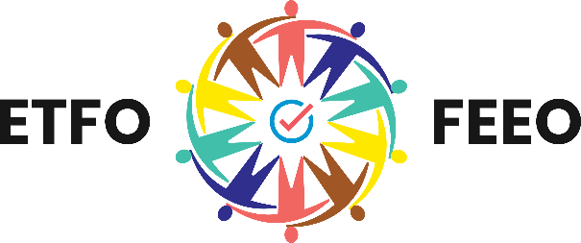
Elementary Teachers’ Federation of Ontario (ETFO)
Fédération des enseignantes et des enseignants
de l’élémentaire de l’Ontario (FEEO)
136 Isabella Street, Toronto, ON, M4Y 0B5
Tel: 416-962-3836 Toll Free: 1-888-838-3836 etfo.ca

February 4, 2022

The Honourable Stephen Lecce
Minister of Education
5th Floor
438 University Ave
Toronto, ON M7A 2A5

Dear Minister Lecce,

On behalf of the 83,000 members of the Elementary Teachers’ Federation of Ontario I am writing to express concerns about the planned implementation of the Education Quality and Accountability Office (EQAO) assessments in grades 3 and 6 this year.

We believe there are significant deficiencies in the planning and preparation of the new format. The continued disruptions to learning during the pandemic require a focus on bringing stability to our schools not disruptive testing. Educators have significant concerns about the well-being and mental health of students, adding EQAO related anxiety and stress at this time is totally irresponsible. Additionally, we have concerns about young students using a digital platform which embeds an algorithm that creates a streamed assessment process.

We urge the Ministry of Education to continue the pause of EQAO assessments for students in grades 3 and 6.

EQAO assessment guides have been delayed and training webinars will not be available until March for elementary educators. Additionally, the modules are to be completed on the educators’ own time at lunch or afterschool.

This follows a pattern, a lack of organization and planning by the Ministry of Education regarding their initiatives. For example, the continued pause on the assessment of social-emotional learning skills in both the Ontario Curriculum, Grades 1-8, Mathematics (2020) and the Ontario Curriculum, Grades 1-8, Health and Physical Education (2019) as directed by the Ministry of Education and no communicated plans for professional development.

Simply put, the government is not prepared to move forward with EQAO in 2022.

ETFO is not alone in advocating for a continued pause of EQAO in 2022. In the Royal Society of Canada (RSC) Policy Briefing, Children and Schools During COVID-19 and Beyond: Engagement and Connection Through Opportunity (August 2021), chapter 7, author Andy Hargreaves (University of Ottawa) recommends a continued pause on EQAO assessments now and after the pandemic. Hargreaves summarizes recent research based on interviews of more than 200 Ontario educators and revealed that not only did EQAO create anxiety, contain cultural bias, and lead to curriculum narrowing and test preparation, it also drove teachers to avoid engaging in innovative projects during—and even immediately before—the years when children were tested. Hargreaves recommends that the engagement and re-engagement with learning is the pathway to achievement. Not large-scale standardized testing of whole cohorts of students.

The OECD recently reported “it has become abundantly clear how important it is during a pandemic to ensure reliability and predictability of educational services.” This predictability is not simply for students and families, but for education workers as well.

However, predictability in education continues to be tenuous. The January 2022 Ministry of Education Update: Return to School, stated that the Office of the Chief Medical Officer of Health (OCMOH) has advised that all sectors must plan for the potential of higher-than-normal levels of absences. Due to the uncontrolled spread of COVID-19 and the new Omicron variant the expectation is for high numbers of students and staff off sick or isolating. These disruptions continue to be significant and persistent.

The continued disruptions to learning during the pandemic require a focus on bringing stability to our schools not disruptive testing that takes away from meaningful classroom assessment informed by teachers’ professional judgement.

ETFO has significant concerns about the experimental move to digitize EQAO tests. This is particularly problematic for Grade 3 students who are expected to type answers to open-response questions. Finding and allocating enough devices will also be a challenge. It will be difficult to ensure all technology is available and in good working order this year, after several distributions and collection periods in response to schools pivoting back and forth between in-person and remote learning. We have additional concerns introducing what is known as Multi-Stage Computer Adaptive Testing (msCAT). In November 2020, EQAO released the literature review Leveraging Multi-Stage Computer Adaptive Testing for Large Scale Assessments which referenced two international large-scale assessments that had adopted an msCAT design, neither of which included elementary-aged students

If the Ontario Government truly wants to place a renewed focus on learning recovery and renewal as stated in the 2021: B07 memo released on May 4, 2021, the Ministry of Education should continue the pause of EQAO assessments for grade 3 and 6 students. The narrow focus of student performance on literacy and numeracy over two decades has led to system fatigue and has undermined teaching and learning of meaningful subjects that support student development and well-being. This spring, students and their educators should be focused on learning together not preparing for tests to measure the system.

Sincerely,

Karen Brown
President

KB:JT:KK

