2026 Black History Month Poster Classroom Ideas

Introduction
This companion document provides multiple ways to engage with the 2026 Black History Month poster in your school and classroom. While the contributions of Black Canadians are highlighted in February, educators should embed these ideas in our classrooms throughout the year. ETFO is intentionally sharing this document after Black History Month to provide activities you can use for the rest of the school year, because African Canadian history is Canadian history.

Part 1
This activity can be used as a whole-school activity over the announcements or in an assembly. Appendix B provides descriptions of the symbols in the poster.

Part 2
These open-ended questions are intended for use in the classroom. They can be used on their own or in combination with one of the additional activities included in this document.

Part 3
This is the Information file that was sent to all schools with the poster.

Part 4
Building on the information that accompanies the poster, these are more comprehensive activities educators can use as lessons or assignments. Curriculum expectations that can be used for these activities are included in Appendix D.

Appendixes A to C
These appendixes provide the original poster and descriptions of the symbolism or significance of various poster elements.

Appendix D
These curriculum connections highlight additional ways that the poster connects to Ontario curriculum. The content is excerpted from the front matter embedded in both the Language and Social Studies curriculums as well as specific expectations at various grade levels.

Appendix E
This is a non-exhaustive list of texts that can and should be used in classrooms throughout the year, not just in February for Black History Month.

Part 1: Suggested Announcement

Day 1
Over the last few weeks, have you had a chance to see the 2026 ETFO Black History Month poster up in our school? It’s called We Didn’t Cross the Waters Alone. The images in the poster span generations and continents to tie together the past, present, and future. Today we will focus on the central figure in the image: A young Black boy imagined as a young griot (gree-oh), spelled g-r-i-o-t, a modern keeper of memory. In many West African cultures, griots are the storytellers, musicians, and living libraries who carry history through voice, rhythm, and oral tradition. The child wears virtual reality goggles, which symbolize dual vision: how history is inherited, how the future is imagined, and how children hold both ancestral memory and possibility at once. His sweater features an embroidered Henson patch, which is meant to represent that he is a descendent of Canadian pioneer Josiah Henson. Tomorrow we will find out more about the poster!

Day 2
Yesterday, we had the chance to explore this year’s ETFO Black History Month poster that is on display ________________ (insert location) in our school. Were you able to find out more about Josiah Henson, the ancestor of our central figure? Today we will focus on Black and Canadian imagery. On the boy’s left, emerging from the frozen lake stands the winter manifestation of Yemoja (yeh-moh-jah), the Orisha (oh-REE-shah) of the great waters, memory, and protection. She is holding a glowing lantern that symbolizes Harriet Tubman’s nocturnal journeys.
The train and railway to the boy’s right reference the railroads that shaped settlement in Canada, including the infrastructure built through Black labour and, in particular, the Black porters who unionized in response to race-based discrimination. The train has steam in the shape of the Tower of Freedom, a monument that recognizes the underground railroad in Windsor, Ontario. Silhouettes of travellers on a frozen bridge represent Black families crossing into new territory, the legacy of the underground railroad, and the courage and vulnerability of leaving one world to enter another.

Day 3
Today, we continue learning about the 2026 Black History Month poster, with a focus on the beautiful natural landscapes highlighted in the image. The winterberries, Canadian Rockies, snow-dusted cattails, northern cardinal, and frozen Great Lakes represent the contrast between the promise of “Canada West” advertised in the early 1900s and the actual northern climate, and the ecosystems that carry histories and stories in their waters and land. This landscape becomes a character – a witness – in the story.

The poster reminds us that our ancestors are always with us. Through migration and the trans-Atlantic slave trade, the Black diaspora has never crossed waters alone.
Note for educators: Please use the QR code on the poster to access the annotated version with additional information and facts you may choose to highlight with your school and/or classroom. This version is also included in this document as Appendix B on page 7.

Part 2: Open-Ended Questions

Primary

Where do you think this poster takes place? What does it make you think of?

What seasons and/or parts of nature do you see in the poster?

Name and describe how different colours and objects are used in the poster.

Junior

What do you first notice about the poster? What questions do you have about it?

Who do you think the woman in the background and the boy in middle are? Write a creative narrative about them.

Name and describe the colours in the poster. How are colour and contrast used to tell a story?

This story has elements of past, present, and future. Find evidence of each and explain why.

Intermediate

When does this scene take place (past, present, future)? What visual elements has the artist included to show this? Explain.

Who do you think the woman in the background and the boy in middle are? Write a creative narrative about them.

What elements of Canadian history and imagery can you find in the poster?

Our central figure is looking through a pair of virtual reality goggles. Based on context from the poster, describe the scene and world he is seeing through those goggles.

Part 3: 2026 Black History Month Poster Information

2026 Black History Month Poster
We Didn’t Cross the Waters Alone

#FutureGriot
The poster is a visual narrative that blends West African cosmology with northern landscapes tied to Black migration routes, such as Windsor–Detroit, Amherstburg, and Chatham–Kent along the Great Lakes.
Central Figure: A young Black boy imagined as a young griot, a modern keeper of memory. In many West African cultures, griots are the storytellers, musicians, and living libraries who carry history through voice, rhythm, and oral tradition. The child wears futuristic virtual reality goggles, which symbolize dual vision: how history is inherited, how the future is imagined, and how children hold both ancestral memory and possibility at once. His sweater is a traditional Nigerian print and his bright orange vest features an embroidered Henson patch, which is meant to represent that he is a descendent of Canadian pioneer Josiah Henson.
The microphone on the patch symbolizes the boy’s voice and his ability to be the sound of his generation. By placing this symbol on an ingenious Black child, the poster reclaims and centres the people who were historically omitted from the narratives in the image. He is not simply observing the scene; he is participating in the retelling of the stories they evoke. In this way, the poster positions the child as a carrier of ancestral memory, a translator of mythology into the present, and a future architect of how history will be told.

Black & Canadian Imagery: On the boy’s left, emerging from the frozen lake stands the winter manifestation of Yemoja, the Orisha (divine spirit) of the great waters, memory, and protection. She is portrayed as a Black woman with long white braids holding a glowing lantern that symbolizes Harriet Tubman’s nocturnal journeys. Her inclusion merges several elements: water as memory, the light in the lantern that guides people across dangerous landscapes, and the unseen spiritual support behind every migration journey.
The train and railway to his right reference the railroads that shaped settlement in Canada, including the infrastructure built through Black labour and, in particular, the Black porters who unionized in response to race-based discrimination. The railway routes also represent the pathways that freedom seekers navigated. The front of the train features the emblem of the Orisha Ogun, the builder, symbolically visualized as iron, tracks and technology, without depicting him directly.
The train grounds the mythic imagery in Canadian history and geography highlighted by the steam in the shape of the Tower of Freedom in Windsor. Silhouettes of travellers on a frozen bridge represent Black families crossing into new territory, the legacy of the underground railroad, and the courage and vulnerability of leaving one world to enter another.
Canadian Landscape & Natural Symbols: The winterberries, Canadian Rockies, snow-dusted cattails, northern cardinal, and frozen Great Lakes represent the contrast between the promise of “Canada West” advertised in the early 1900s and the actual northern climate, and the ecosystems that carry histories and stories in their waters and land. This landscape becomes a character – a witness – in the story.
The poster reminds us that our ancestors are always with us. Through migration and the trans-Atlantic slave trade, the Black diaspora has never crossed waters alone.
Part 4: Activities for the 2026 Black History Month Poster Symbols
No. | Symbol | Description
1 | Black Smoke (Tower of Freedom)  https://www.etfo.ca/news-publications/publications/posters-black-history-month/1-black-smoke-tower-of-freedom | Represents the historic smoke signals from the Tower of Freedom in Windsor, Ont., used as a symbol of hope and freedom for those crossing into Canada via the Underground Railroad.
 | Historical Black Canadian Sites | The Tower of Freedom is a reminder that there is Black History all over the province.  - Research and describe the history of the Tower of Freedom.  - Research Black contributions, societies, and/or symbols in your community.
2 | Great Western Railway Locomotive  https://www.etfo.ca/news-publications/publications/posters-black-history-month/2-great-western-railway-locomotive | The train is an exact rendition of the 1854 Great Western Railway locomotive, one of the early engines built in Canada.
 | Black Train Connections | Black Canadians have made several contributions to society through railways and trains.  - Research the history of how and why Black sleeping car porters were motivated to create their own union.  - Several notable Black Canadians worked as porters including Stanley Grizzle. Describe how they were treated while in their jobs and how this may have contributed to their future success.
3 | VR Goggles – Future Worldbuilding  https://www.etfo.ca/news-publications/publications/posters-black-history-month/3-vr-goggles-future-worldbuilding | The child wearing virtual reality goggles represents imagination, innovation, and new ways of seeing. A symbol of worldbuilding and the next generation shaping the future.
 | Future Technology | Creative Writing Task  - What do you think the young man is seeing through his goggles? Describe the future that you would love to imagine for yourself and society through the VR goggles.
4 | Henson Patch & Microphone  https://www.etfo.ca/news-publications/publications/posters-black-history-month/4-henson-patch-microphone | A reference to Josiah Henson and the generations connected to the Henson legacy of liberation. Symbolizes lineage, memory, and return.  The microphone connects to the boy to being a future griot, (West African storyteller, memory-keeper, historian). As a griot, he also represents being the voice of his generation.
 | Henson: One name and two Black Canadian heroes | - Research Josiah Henson. Create a Venn diagram between him and Harriet Tubman.  - Aside from the experiences that parallel Harriet Tubman, complete a short biography on Josiah Henson.
5 | Ankara Print  https://www.etfo.ca/news-publications/publications/posters-black-history-month/5-ankara-print | Ankara is one of West Africa’s most recognizable textiles.  Although originally produced by Dutch factories trying to mimic Indonesian batik, it was rejected in Indonesia and embraced across West and Central Africa instead. There, communities claimed it and shaped it into a fabric of identity, pride, politics, and celebration.
 | West African Print and fashion | The Ankara print represents a fascinating progression of the effects of colonization. While the Dutch were in West Africa to exploit the area, their print, which was not well regarded at the time, was embraced by Africans who made it something new and popular.  - Are there other examples of creations introduced through colonization that have evolved over time?  - Fashion is one way that Black people have shared their creativity with the world through the arts. Research and describe a prominent figure in an art form (dance, music, fashion, visual art, dramatic arts).
6 | Lantern (Harriet Tubman)  https://www.etfo.ca/news-publications/publications/posters-black-history-month/6-lantern-harriet-tubman | The lantern symbolizes Harriet Tubman’s leadership, guidance, and the many night journeys she made leading people to freedom as a conductor on the Underground Railroad. Tubman’s rescue missions spanned roughly 1850 to 1860, guiding enslaved people from the United States into safe communities throughout Ontario (then called Canada West). The lantern also serves as a reminder of how Tubman, an amazing naturist, would intentionally pause to connect with her natural surroundings to chart courses to safety. The lantern is a reminder of both literal and spiritual light during the darkest passages of escape.
 | Black Environmentalists/Naturists | The Underground Railroad, led by Harriet Tubman, has often been seen through a brave and courageous lens. Evaluate how she developed and maintained the underground railroad using her profound understanding of nature and the world around her. Why do you think history hasn’t popularized Tubman’s understanding of nature?  Who are some modern Black environmentalists making contributions to the current and future state of the world?
7 | Bridge of Migrants  https://www.etfo.ca/news-publications/publications/posters-black-history-month/7-bridge-of-migrants | Figures walking across the bridge over the water symbolize migration, intergenerational movement, and the journeys taken toward new futures.
 | Migration Stories and Journeys | Over the course of thousands of years, people have migrated throughout the world often seeking opportunity or escaping trouble. Research and share a true story of migrants. Include the following details: point of departure, their destination, the reasons they’re leaving and their journey.
8 | Yemoja  https://www.etfo.ca/news-publications/publications/posters-black-history-month/8-yemoja | Yemoja, the Mother of Waters from the West African pantheon, is reimagined here as Ayaba Mayafra, the Queen of Snow. In this story, she arrives in the northern, ice-covered lands, symbolizing:  - resilience across climates  - ancestral protection  - the adaptation of African spiritual traditions in new worlds  Folklores across the diaspora say Yemoja travelled spiritually across the Middle Passage to be with enslaved children and protect them through hardship. She is celebrated throughout the Americas as Yemaya, the Water Mother who watches over migrants, coastlines, and those who cross oceans seeking freedom.
 | West African Folklore and Tradition | Many cultures have beliefs about gods, spiritual leaders, or heroes that are shared through oral storytelling traditions like fables and folk stories.  Primary Activity  Yemoja is the Mother of Waters. What could someone who controls water do with that power?  There are other examples of the natural world in the poster, including mountains, flowers, and a bird. If you could have a superpower connected to nature, what would it be?  Junior Activity  There are other examples of the natural world in the poster, including mountains, flowers, and a bird. If you could add another natural element, and give yourself a superpower connected to nature, what would it be and why?  Intermediate Activity:  Due to climate change, we are regularly seeing significant weather patterns change over time. Write a narrative featuring Yemoja as a prominent hero and addressing the climate crisis as a key theme.  Ogun (oh-GOON) is another Orisha featured on the front of the train. Research him or another Orisha and try to reimagine them in a Canada’s current setting.
9 | Cowrie Shell  https://www.etfo.ca/news-publications/publications/posters-black-history-month/9-cowrie-shell | Represents wealth, trade, femininity, protection, and sacred value across Africa and the diaspora. A symbol of both currency and spiritual power.  Cowrie shells were used as money across West Africa from about the 10th century into the early 20th century. They were one of the longest-circulating forms of currency on the continent.
 | Traditional Symbols | The cowrie shell is a symbol that has extreme reverence in West African culture. Research a symbol from either your own culture or here in Ontario that has great value and is both protected and held in high esteem.  The cowrie shell is a reminder that “money” is an arbitrary symbol, especially now that it often isn’t used in physical forms, but through bank cards and digital transactions.
10 | Northern Cardinal  https://www.etfo.ca/news-publications/publications/posters-black-history-month/10-northern-cardinal | A bird that lives between water and land. In West African belief, cardinals are messengers of ancestors. Also, a subtle symbol of migration and spiritual presence.
 | Animals that carry spiritual significance | Did you know that Ontario has a provincial bird and flower? Research either and include why it was chosen to symbolize the province.  The cardinal is an animal known for connecting messages spiritually between the ancestors and present day. Animals and parts of the natural world typically have additional meaning and significance in most cultures.  Choose an animal. Research the significance that it holds within society and share your learning.

Appendix A
2026 Black History Month Poster
We Didn’t Cross the Waters Alone
#FutureGriot
The poster is a visual narrative that blends West African cosmology with northern landscapes tied to Black migration routes, such as Windsor–Detroit, Amherstburg, and Chatham–Kent along the Great Lakes.
Central Figure: A young Black boy imagined as a young griot, a modern keeper of memory. In many West African cultures, griots are the storytellers, musicians, and living libraries who carry history through voice, rhythm, and oral tradition. The child wears futuristic virtual reality goggles, which symbolize dual vision: how history is inherited, how the future is imagined, and how children hold both ancestral memory and possibility at once. His sweater is a traditional Nigerian print and his bright orange vest features an embroidered Henson patch, which is meant to represent that he is a descendent of Canadian pioneer Josiah Henson.
The microphone on the patch symbolizes the boy’s voice and his ability to be the sound of his generation. By placing this symbol on an ingenious Black child, the poster reclaims and centres the people who were historically omitted from the narratives in the image. He is not simply observing the scene; he is participating in the retelling of the stories they evoke. In this way, the poster positions the child as a carrier of ancestral memory, a translator of mythology into the present, and a future architect of how history will be told.
Black & Canadian Imagery: On the boy’s left, emerging from the frozen lake stands the winter manifestation of Yemoja, the Orisha of the great waters, memory, and protection. She is portrayed as a Black woman with long white braids holding a glowing lantern that symbolizes Harriet Tubman’s nocturnal journeys. Her inclusion merges several elements: water as memory, the light in the lantern that guides people across dangerous landscapes, and the unseen spiritual support behind every migration journey.
The train and railway to his right references the railroads that shaped settlement in Canada, including the infrastructure built through Black labour and, in particular, the Black porters who unionized in response to race-based discrimination. The railway routes also represent the pathways that freedom seekers navigated. The front of the train features the emblem of the Orisha Ogun, the builder, symbolically visualized as iron, tracks and technology, without depicting him directly.
The train grounds the mythic imagery in Canadian history and geography highlighted by the steam in the shape of the Tower of Freedom in Windsor. Silhouettes of travellers on a frozen bridge represent Black families crossing into new territory, the legacy of the underground railroad, and the courage and vulnerability of leaving one world to enter another.
Canadian Landscape & Natural Symbols: The winterberries, Canadian Rockies, snow-dusted cattails, northern cardinal, and frozen Great Lakes represent the contrast between the promise of “Canada West” advertised in the early 1900s and the actual northern climate, and the ecosystems that carry histories and stories in their waters and land. This landscape becomes a character – a witness – in the story.

The poster reminds us that our ancestors are always with us. Through migration and the trans-Atlantic slave trade, the
Black diaspora has never crossed waters alone.

Appendix B

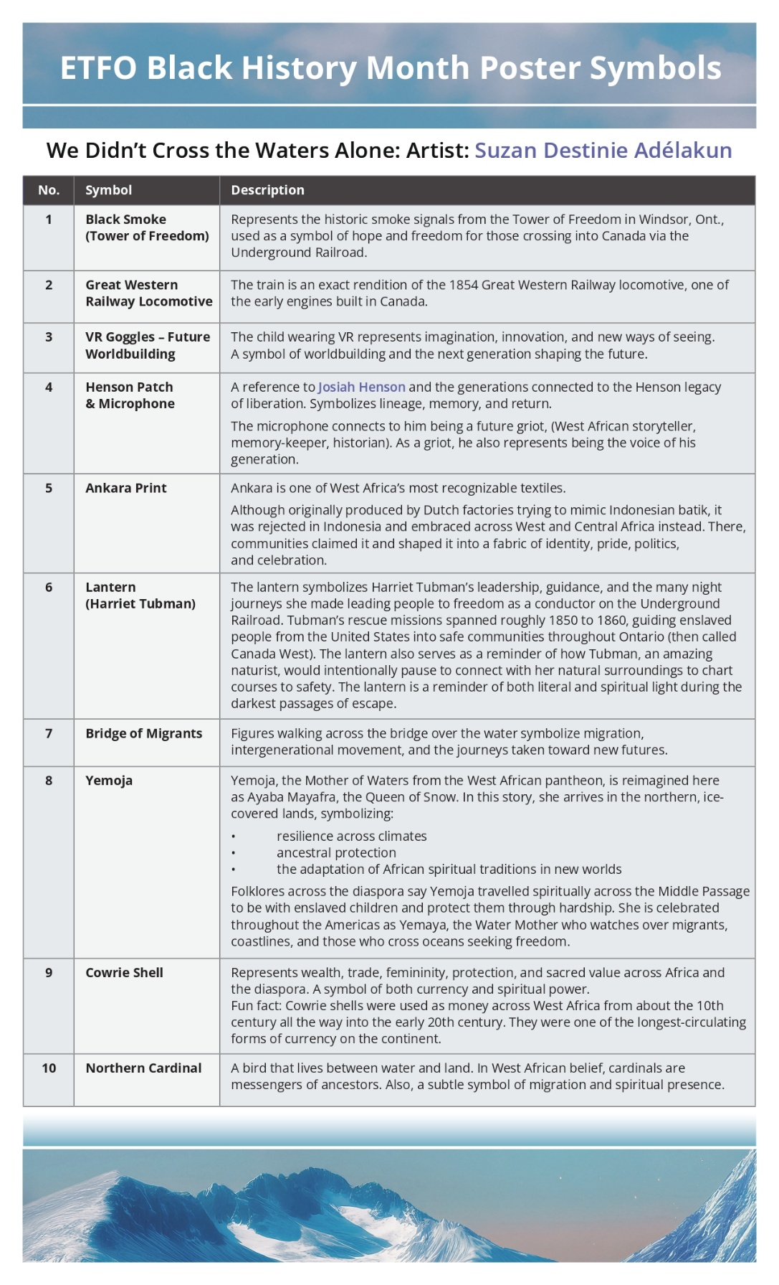

Appendix C

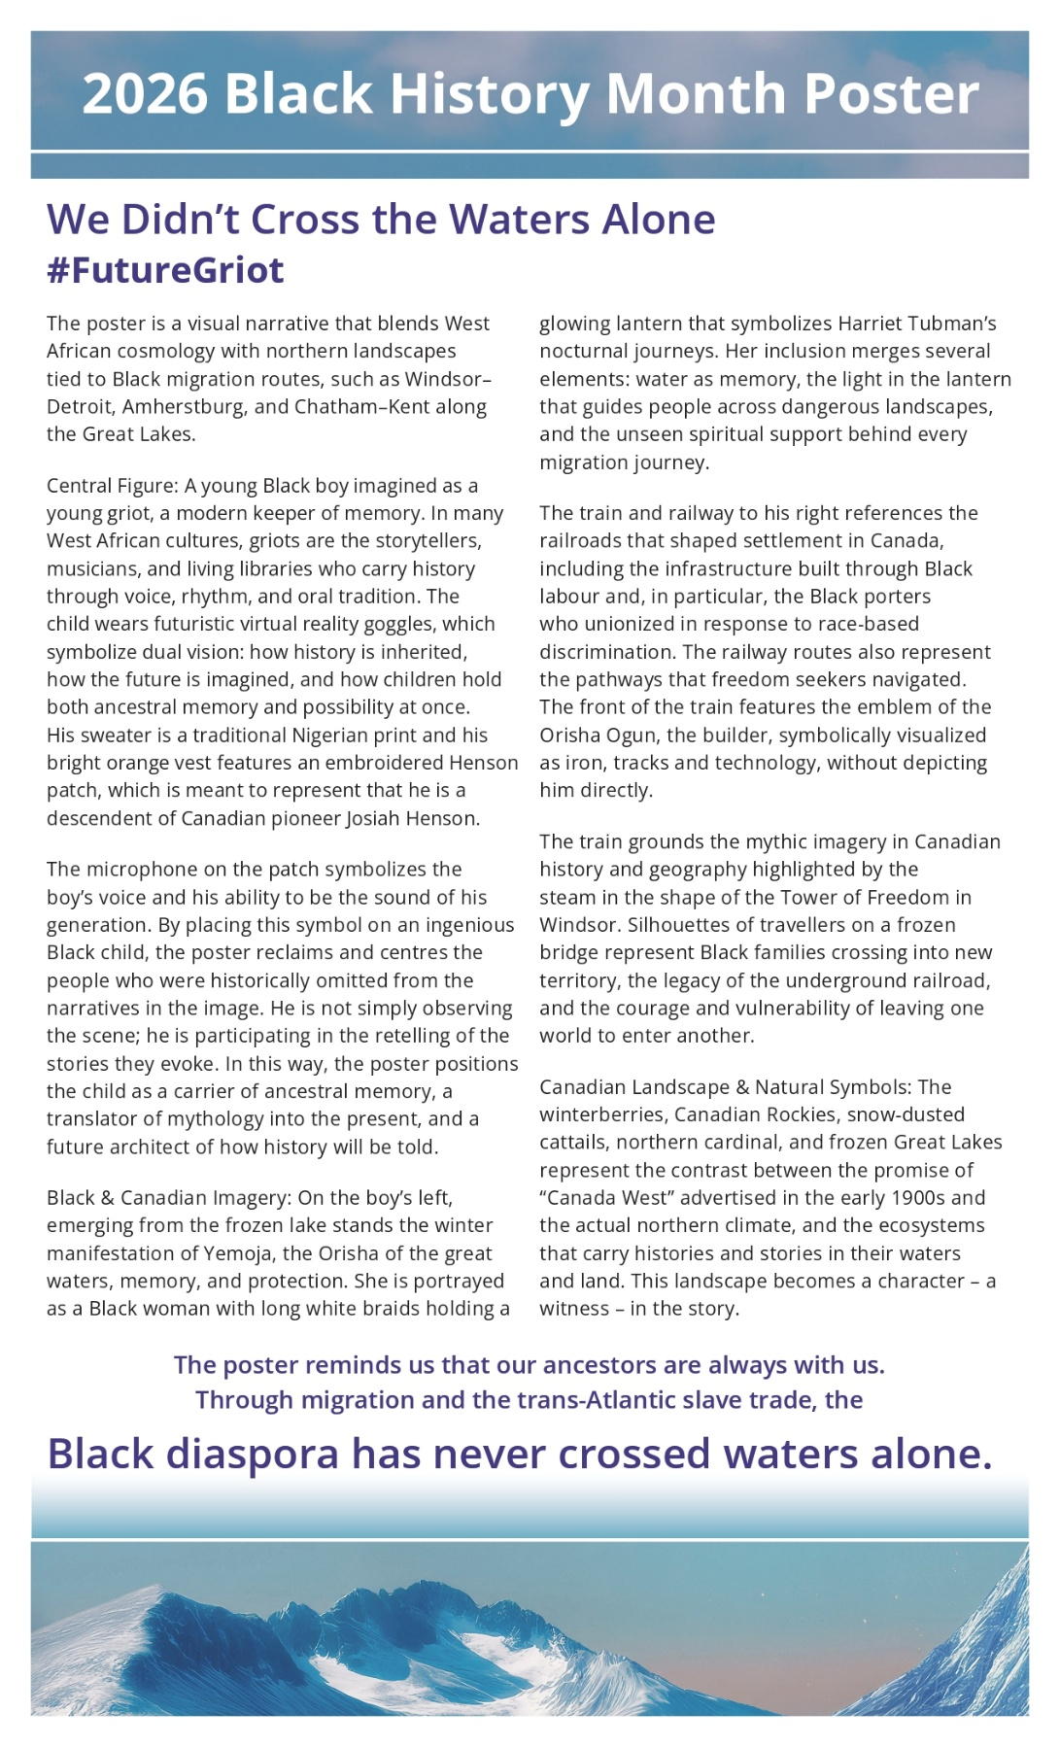

Appendix D

Please note that the following content from the Ontario curriculum is intended to reinforce not just the importance of engaging in African Canadian learning year-round but also serve as a reminder for the ways in which equity work is part of the curriculum. Next year, we anticipate being able to share the new Grade 7 and 8 specific expectations on Black Canadian history that will be added to the History/Geography curriculum.

Curriculum Connections
One barrier that has been historically expressed to engaging with new, diverse content is educators not always seeing the ways they can bring the curriculum to life. Below are a variety of excerpts from the curriculum that can aid in the creation of activities that may integrate this year’s Black History Month poster.
The following are relevant excerpts and expectations from the Ontario Language and Social Studies curriculums and the updated considerations for program planning document.

English Language Learners in Ontario Schools
Ontario schools have some of the most multilingual student populations in the world. The first language of approximately 28 per cent of the students in Ontario’s English-language schools is a language other than English. In addition, some students use varieties of English – sometimes referred to as dialects – that differ significantly from the English required for success in Ontario schools. Many English language learners were born in Canada and have been raised in families and communities in which languages other than English, or varieties of English that differ from the language used in the classroom, are spoken. Other English language learners arrive in Ontario as newcomers from other countries; they may have experience of highly sophisticated educational systems, or they may have come from regions where access to formal schooling was limited.
When they start school in Ontario, many of these students are entering a new linguistic and cultural environment. All teachers share in the responsibility for these students’ English-language development.
As students who are learning English as a second or additional language in English-language schools, English language learners bring a rich diversity of background knowledge and experience to the classroom. These students’ linguistic and cultural backgrounds not only support their learning in their new environment but also become a cultural asset in the classroom community. Effective teachers find positive ways to incorporate this diversity into their instructional programs and into the classroom environment.
Most English language learners in Ontario schools have age-appropriate proficiency in their first language, as well as age-appropriate literacy skills. Although they need frequent opportunities to use English at school, they also derive important educational and social benefits from continuing to develop their first language while they are learning English. Teachers should encourage parents to continue to use their own language at home, both to preserve the language as part of their children’s heritage and identity and to provide a foundation for their language and literacy development in English. It is also important for teachers to find opportunities to bring students’ languages into the classroom, using parents and community members as a resource.

Human Rights, Equity, and Inclusive Education
A positive, inclusive, equitable, and non-discriminatory elementary and secondary school experience is vitally important to a student’s personal, social, and academic development, to their future economic security, and to a realization of their full potential. Human rights principles recognize the importance of creating a climate of understanding and mutual respect for the dignity and worth of each person, so that each person can contribute fully to the development and well-being of their community. Indeed, human rights law guarantees a person’s right to equal treatment in education. It requires educators and school leaders to prevent and respond appropriately to discrimination and harassment, to create an inclusive environment, to remove barriers that limit the ability of students, and to provide accommodations, where necessary.
Ontario’s education system, at all levels, must respect diversity, promote inclusive education, and work towards identifying and eliminating barriers to equal treatment in education that limit the ability of students to learn, grow, and contribute to society. Discriminatory biases, harassment, non-inclusive environments, lack of accommodation, systemic barriers, power dynamics, societal poverty, and racism make it difficult for students to acquire the skills they need to be successful, competitive, and productive members of society. Ontario schools aim to improve the academic outcomes and experiences of students who have traditionally not benefited from the promise of public education.
In an environment based on the principles of inclusive education, all students, parents, caregivers, and other members of the school community – regardless of ancestry, culture, ethnicity, sex, disability, race, colour, religion, age, marital or family status, creed, gender identity/expression, gender, sexual orientation, socio-economic status, or other factors – are welcomed, included, treated fairly, and respected. Diversity is valued when all members of the school community feel safe, welcomed, and accepted. Every student is supported and inspired to succeed in a culture of high expectations for learning.
Research has shown that students who do not see themselves reflected in what they are learning, in their classrooms, and in their schools become disengaged and do not experience as great a sense of well-being or as high a level of academic achievement as those who do.

Culturally Responsive and Relevant Pedagogy (CRRP)
In an inclusive education system, students must see themselves reflected in the curriculum, their physical surroundings, and the broader environment, so that they can feel engaged in and empowered by their learning experiences. Students need to experience teaching and learning that reflect their needs and who they are. To ensure that this happens, educators in Ontario schools embrace culturally responsive and relevant pedagogy (CRRP), which recognizes that all students learn in ways that are connected to background, language, family structure, and social or cultural identity.
CRRP provides a framework for building positive environments, improving student responsibility and success, encouraging parent-school relationships, and building strong community connections. It also emphasizes that it is important for educators and school leaders to examine their own biases and to analyze how their own identities and experiences affect how they view, understand, and interact with all students. This can help to prevent discrimination, harassment, and the creation of poisoned environments. Educators are responsible for meaningful teaching and learning that recognizes and responds to who is in the classroom and the school.
By knowing “who our students are,” educators and leaders can tailor policies, programs, and practices to better meet the needs of their diverse student populations, to provide accommodation of the needs specified by human rights law, and to ensure that every student has the opportunity to succeed. CRRP involves recognizing that “culture” encompasses various aspects of social and personal identity. It also means acknowledging students’ multiple social and personal identities and the social issues that arise where identities intersect. The CRRP approach is designed to spark conversation and support educators and school leaders as they seek to implement effective equity strategies and policies. Educators are encouraged to engage in meaningful inquiry, in collaboration with colleagues, to address equity issues and the particular needs of the students they serve.

Implementing Principles of Inclusive Education
The implementation of inclusive education principles in education influences all aspects of school life. It promotes a school climate that encourages all students to work to high levels of achievement, affirms the worth of all students, and helps students strengthen their sense of identity and develop a positive self-image. It encourages staff and students alike to value and how respect for diversity in the school and the broader society. Inclusive education promotes equity, healthy relationships, and active, responsible citizenship. The absence of inclusive approaches to education can create discriminatory environments, in which certain individuals or groups cannot expect to receive fair treatment or an equitable experience based on aspects of their identity.
Teachers can give students a variety of opportunities to learn about diversity and diverse perspectives. By drawing attention to the contributions and perspectives of historically marginalized groups, and by creating opportunities for their experiences to be affirmed and valued, teachers can enable students from a wide range of backgrounds to see themselves reflected in the curriculum. It is essential that learning activities and materials used to support the curriculum reflect the diversity of Ontario society. In addition, teachers should differentiate instruction and assessment strategies to take into account the background and experiences, as well as the interests, aptitudes, and learning needs, of all students.

Media Literacy Curriculum Expectations

Digital Media Literacy (Grade 4)
A2 demonstrate and apply the knowledge and skills needed to interact safely and responsibly in online environments, use digital and media tools to construct knowledge, and demonstrate learning as critical consumers and creators of media.

Community and Cultural Awareness (Grade 5)
A2.7 communicate and collaborate with various communities in a safe, respectful, responsible, and inclusive manner when using online platforms and environments, including digital and media tools, and demonstrate cultural awareness with members of the community.

Media, Audience, and Production (Grade 6)
A2.5 demonstrate an understanding of the interrelationships between the form, message, and context of texts, the intended audience, and the purpose for production.

Media Literacy (Grade 7)
A2.4 evaluate the use of the various forms, conventions, and techniques of digital and media texts, consider the impact on the audience, and apply this understanding when analyzing and creating texts.

Media Literacy (Grade 8)
A2.5 demonstrate an understanding of the interrelationships between the form, message, and context of texts, the intended and unintended audience, and the purpose for production.

Social Studies Curriculum Expectations

A1. Application: Diversity, Inclusiveness, and Canadian Identities (Grade 6)
Explain how various groups and communities, including First Nations, Métis, and Inuit communities, have contributed to the goal of inclusiveness in Canada (e.g., with reference to the efforts of women’s rights, civil rights, Indigenous, or labour organizations, or of advocacy organizations for immigrants, disabled people, or various religious or ethnic groups; the Métis idea of and belief in respectful blending), and assess the extent to which Canada has achieved the goal of being an inclusive society (e.g., with reference to the policy of multiculturalism, the Canadian Charter of Rights and Freedoms, the Ontario Human Rights Code, the Ontarians with Disabilities Act, freedom of religion, the recognition of gay marriage, the ratification of the United Nations Declaration on the Rights of Indigenous People).

A1.3 History (Grade 7)
Analyze the displacement experienced by various groups and communities, including First Nations, Métis, and Inuit communities, who were living in or who came to Canada between 1713 and 1800 (e.g., the expulsion of the Acadians; the forced relocation experienced by many First Nations and/or Métis to reserves or different territories; the migration of Loyalists to various regions of Canada; the forced migration of African slaves to New France and British North America; the immigration of people to Canada seeking land, religious freedom, and/or work), and compare it with present-day examples of displacement (e.g., the relocation of a First Nation reserve community in Canada as a result of changing environmental or economic conditions; the experience of and services available to immigrants or refugees to Canada).

B1.2 (Grade 8)
Analyze how various factors have affected the economies of specific developed and developing countries around the world.

Appendix E

Resource List
All resources for younger grades can be used in older divisions.
Abena’s Adventures: A Taste of Home, Blessing Tabi Owusu

Bros, Carole Boston Weatherford; Reggie Brown, illus.
Julián Is A Mermaid, Jessica Love
La Détermination de Viola Desmond, Jody Nyasha Warner; Richard Rudnicki, illus.; Louise Binette,
Texte Français
Leo and the Pink Marker, Mariyka Foster
Meet Viola Desmond, Elizabeth MacLeod; Mike Deas, illus.

My Code Word for When I’m Scared or Afraid, Lyn Joseph; Annalize McLean, illus.
R is for Reparations: Young Activists Speaking Their Truth, Global Afrikan Congress – Nova Scotia Chapter with the Book-in-a-Day Children
What’s in the Cookie Tin?, Yolanda T. Marshall; Golnoush Moini, illus.
The Vast Wonder of the World: Biologist Ernest Everett Just, Mélina Mangal; Luisa Uribe, illus.

Kafiya Meets the Moon, Janet Campbell; Anais Lee, Illus.

More than Words: So Many Ways to Say What We Mean, Roz MacLean
Dear Black Child, Rahma Rodaah; Lydia Mba, illus.
Hidden Figures: The True Story of Four Black Women and the Space Race, Margot Lee Shetterly
with Winnifred Conkling; Laura Freeman, illus.

Curriculum Connections content courtesy of the Ontario Ministry of Education.

